

**POLITECNICO DI MILANO**

**Project of:**

**Mechanical System Dynamics**



**Application of Experimental Modal Analysis Technique**



**Academic year 2018/2019**

***Students: Professors:***

**Seyyed Jalaladdin Abbasi Koumleh Prof. Roberto Corradi**

**Gabriele Ceruti Prof. Michele Vignati**

**Andrea Codina**

**Emanuele Di Lorenzo**

**Index**

**Introduction** 4

**Experimental setup design** 4

**Input force** 5

**Accelerometers** 5

**Data collection and processing** 6

**DH1 configuration** 6

**Simplified single mode identification procedure** 9

**1.** 10

**2.** 12

**Half power points formula** 10

**Slope of the phase diagram method** 11

**Comparison between the two methods** 13

**3.** 16

**Computation of the analytical solution and final comparison** 14

# **Introduction**

Experimental modal analysis (EMA) is a procedure used to characterize the dynamic properties of a mechanical system. This project is focused on the identification of the modal parameters:

* natural frequencies ;
* damping ratios ;
* mode shapes

The identification of the modal parameters is done by analyzing the experimental frequency response functions in frequency domain.

# **Experimental setup design**

The mechanical system considered is an aluminum beam with a rectangular cross section.

In the image below are reported the beam and its properties.

During the experiment the beam rests on two flexible sponge supports. It can be assumed that the supports do not constrain the movement of the ends and do not react to any forces and moments: for this reason, the system is considered as a free-free beam.

### **Input force**

The input impulse force is given by a dynamometric hammer. It is used an impulse because it can provides energy inside the system in a continuous and wide frequency range: the harder is the tip of the hammer, the higher is the maximum frequency at which the system is excited, because it is able to provide a “more ideal” impulse.

In this experiment it is used a hammer with an intermediate tip (# 2, black line), that excite the system until 400 Hz.

Two different configurations are considered, DH1 and DH2: they are different in terms of position of the force. This report will be focused on the analysis of the DH1 configuration.

In the table below are reported the data concerned the position of the two forces and the sensitivity of the piezoelectric accelerometers used to measure it:

### **Accelerometers**

The three accelerometers are composed by a piezoelectric crystal: the deformation of the crystal provides an electrical signal measured by the electrodes. The crystal is very rigid, with resonance frequencies in the order of the kHz: in the range of frequencies we are interested in (from tenths until hundreds of Hz) the crystal works in quasi static region and so the accelerometers will not vibrate and they will measure only the acceleration of the beam. This type of accelerometers can measure only relative accelerations, so they cannot measure any rigid motion of the beam.

The accelerometers are placed only on the first half of the beam. The reason is that the system analyzed is symmetric, and so the mode shapes are supposed to be symmetric and antisymmetric: by knowing the output in the first half of the beam is possible to compute the output in the second half.

In the following table the position and the characteristic of each accelerometer is reported:

# **Data collection and processing**

The measurements are performed so as to collect a set of N input and N output data for each combination of input force location (DH1, DH2) and for every output acceleration measurement (A1, A2, A3). The length of each time history is indicated with .

The Hanning window is used to minimize the problem of spectral leakage, that can cause a decrease of the coherence function near the resonances.

For every k-j combination are computed 2N discrete Fourier transforms, obtaining the discrete spectra of input and output (), with a resolution frequency .

PSD (Power Spectral Density – real) and CSD (Cross Spectral Density – complex) functions are computed in the following way:

Finally, the experimental FRF (using the H1 estimator) and the coherence function are estimated:

The H1 estimator it is useful to filter out the noise at the output due to electrical disturbances, especially when is very low or equal to zero and the accelerometer at the output measures only noise.

# **DH1 configuration**

The magnitude, in terms of inertance (), phase and coherence of the experimental FRFs for the three accelerometers are reported below.

All the magnitude diagrams are reported in DB (DeciBell) in order to better highlight the presence of small peaks.

It is immediately possible to notice that A3 measure only three peaks instead of the five measured by A1 and A2. This happens because the A3 is positioned on half of the beam ().

Due to the symmetry of the system, the even modes and are antisymmetric and so since A3 is positioned on a node for that modes, the contribution of these modes to the response in that point is null.

Taking in account the analytical formulation of the FRF using the modal superposition approach:

In correspondence to natural frequency, the contribution to the response given by the resonant mode only is:

The consequence is that it makes no sense to compute the natural frequencies and the damping ratios for the accelerometer A3 since the response measured in that frequency values is only given by the non-resonant modes.

The coherence function express the level of physical correlation between input and output. It is defined between

no correlation, the devices are measuring only noise;

perfect correlation, neither leakage nor noise.

All the coherence functions , except for small frequencies values () and for very high ones (), are very near to one: it means that in the region the correlation between input and output is very good and reliable and the effect of disturbances in general is very low.

Huge drops of the coherence functions are due to the fact that the system is not vibrating in correspondence of that frequencies because and so the response measured by the accelerometers is only due to the noise that is completely uncorrelated with the input force.

# **Simplified single mode identification procedure**

This method allows to identify the modal parameters by focusing on a single mode per time. It is possible to apply this procedure if the following assumptions are respected:

* The modes of the system are located at natural frequencies sufficiently far from each other. This implies that all the higher modes contribute to the response in quasi static regions, and all the lower modes contributes to the response in seismographic region.
* The system is lightly damped.

This implies that the peaks are very high and the contributes of the other non-resonant modes is very low compared to the resonant one.

If these assumptions are valid the contribution of the resonant mode in neighborhood of the natural frequencies is a lot larger than the other contributes. So it is possible to consider a single mode per time in a narrow frequency band centered in correspondence of the resonance:

## **Identification of the natural frequencies**

The method consists in identifying the frequencies at which the magnitude diagram of the FRFs shows peaks. Then once the modal damping ratios are known the natural frequencies as: . Actually if are very low is still a good approximation.

**Table of results**

In all the magnitude diagrams is visible a small peak around 10 Hz. That might be caused by the sponge constraints that don’t allow the beam to translate in a rigid way (as a perfect free-free beam would do) and the peak that should be in correspondence of is shifted a bit to the right. In addition, all the coherence diagrams show a drop around 13 Hz and so that peak measurement might be in any case not reliable due to a high presence of noise and leakage.

## **Identification of the damping ratios**

To identify the damping ratios is possible to apply two different methods:

* Half power points formula.
* Slope of the phase diagram method.

### **Half power points formula**

This formula allows to compute the damping ratios by looking at the sharpness of the resonance peaks in the magnitude diagram of the FRFs

**Graphical representation of half power method**

(in the specific example is reported the peak at the frequency by accelerometer A1).

If and are the frequencies *Ω* at which :

From that data is possible to compute :

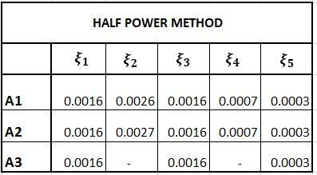

Since the values of damping ratio are very low (below 5%) it is possible to say that:

### **Slope of the phase diagram method**

By taking the simplified expression of the FRF in the neighborhood of the natural frequencies:

So in order to compute is necessary to compute the slope of the phase diagram when , or in other words when the phase is (or , since Matlab shows only a phase range between and ) and is decreasing of .

In the images below are reported the diagrams of the phases underlighting the straights tangent to the phase (in black) in correspondence of the natural frequencies:

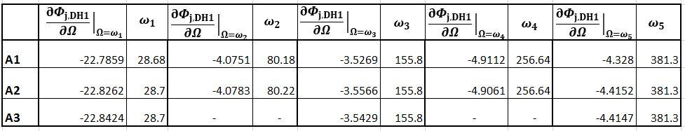

### **Comparison between the two methods**

By comparing the values of obtained in two methods, not significant variations has been met, exception made for the last damping ratio: computed with the half power points method is approximately half of the one computed with the phase tangent method. This can be due to the fact that for very small values of damping (below than 1%) it is not possible to compute in a precise way the damping starting from the experimental FRF .

## **Mode shapes identification**

The final step of modal identification consists in computing the mode shapes from the experimental FRFs and compare them with the analytical solution.

By considering the simplified expression of the FRFs, valid in the neighborhood of the natural frequencies

The quantity inside the round brackets is constant for each mode *i*.

Since each mode shape is defined but for a constant, by taking the imaginary part of the FRF is possible to find the mode shape *i* evaluated in correspondence of the accelerometers’ position.

For mode *i*:

# **Computation of the analytical solution and final comparison**

By imposing the standing wave solution:

The only way to have always two functions of different variables equal is to have them equal to the same constant, called .

Imposing the relationship and separating the two differential equations in *x* and *t* :

The general solution is:

By imposing the boundary conditions related to a free-free beam is possible to find the values of the constants A, B, C, D.

By collecting all the constants in a vector

The only way to not have a trivial solution ( is that:

The solutions of the equation (with ) will define the natural frequencies of the system. In the frequency range considered () the are visualized in an easy way in the logarithmic plot:

due to the rigid motion allowed by the constrains;

Now is possible to compute the vector of constants for every solution

By imposing one of the rows of the matrix is linear dependent to the other rows: therefore is possible to eliminate one row of the matrix, for example the first one, without changing the solution of the system. The system is overdetermined, it has 1 degree of freedom. By imposing one of the constants, for example A equal to 1, it is possible to find all the other constants as a function of A:

By imposing all , the following solutions have been computed:

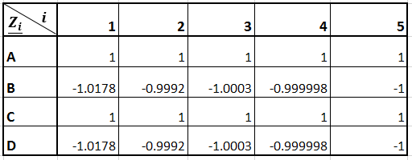

Then finally is possible to compute the mode shapes:

By comparing the experimental and analytical mode shapes obtained:

